# EXERCISE-4 Writing Basic SQL SELECT Statements

1. The following statement executes successfully. Identify the Errors SELECT employee_id, last_name sal*12 ANNUAL SALARY FROM employees; Queries

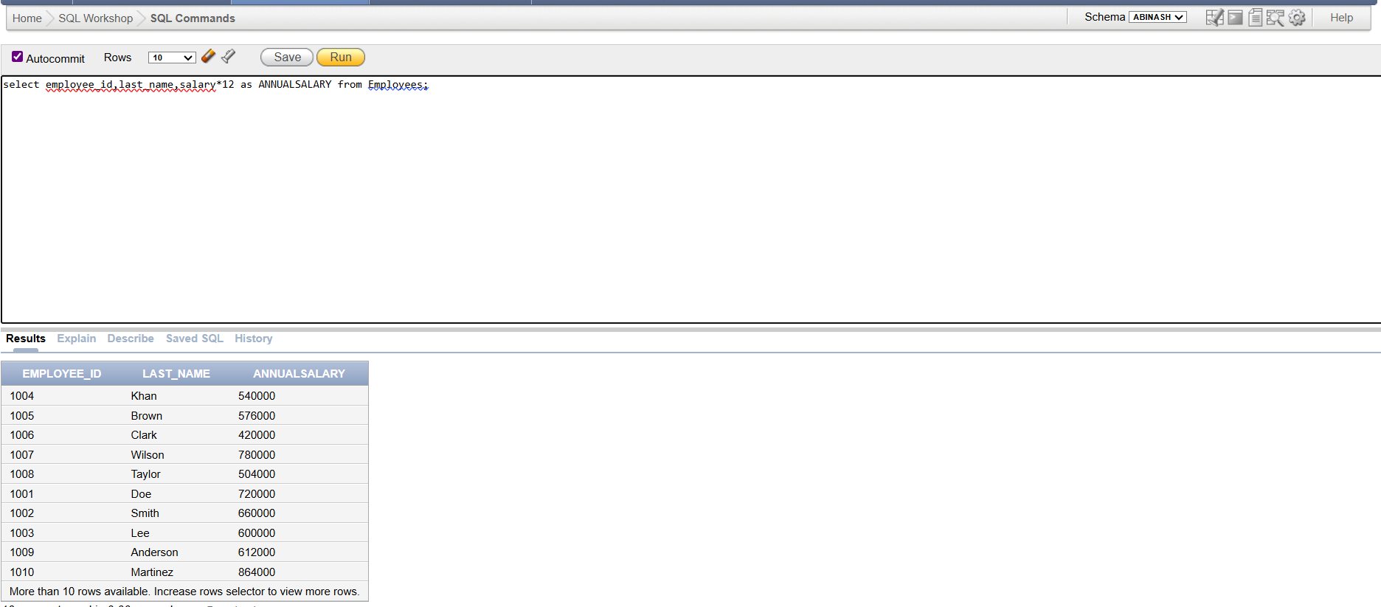

2.Show the structure of departments the table. Select all the data from it.

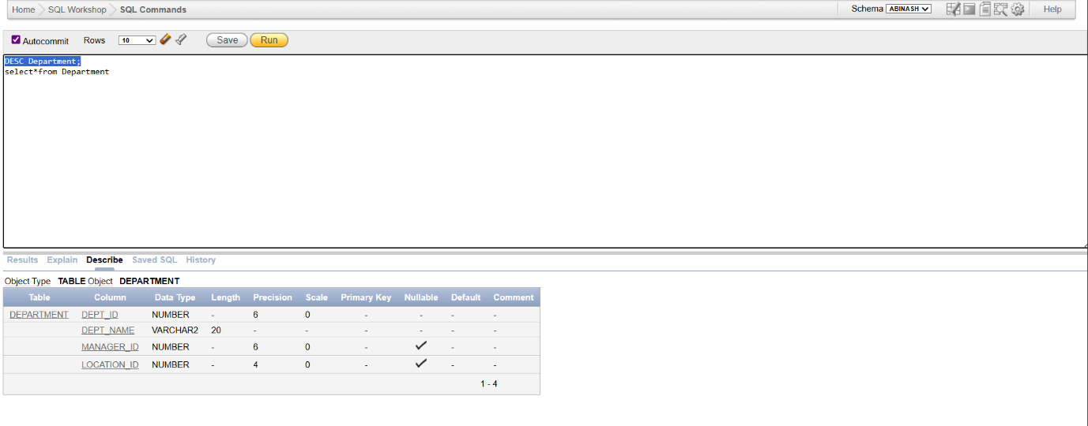

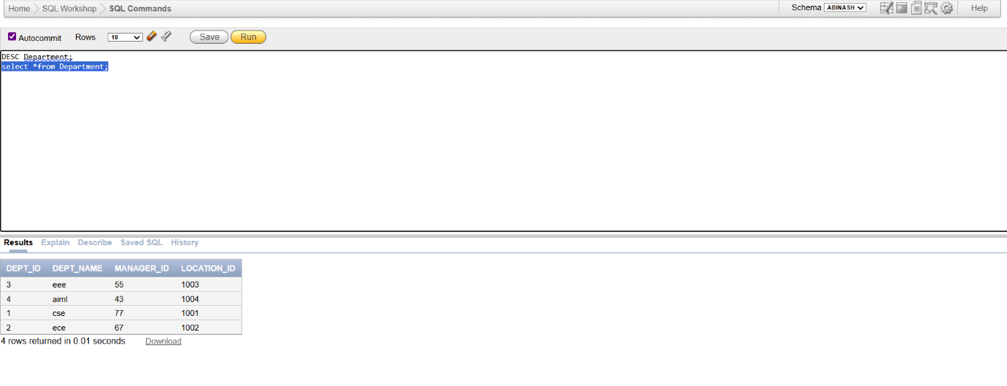

3.Create a query to display the last name, job code, hire date, and employee number for each employee, with employee number appearing first.

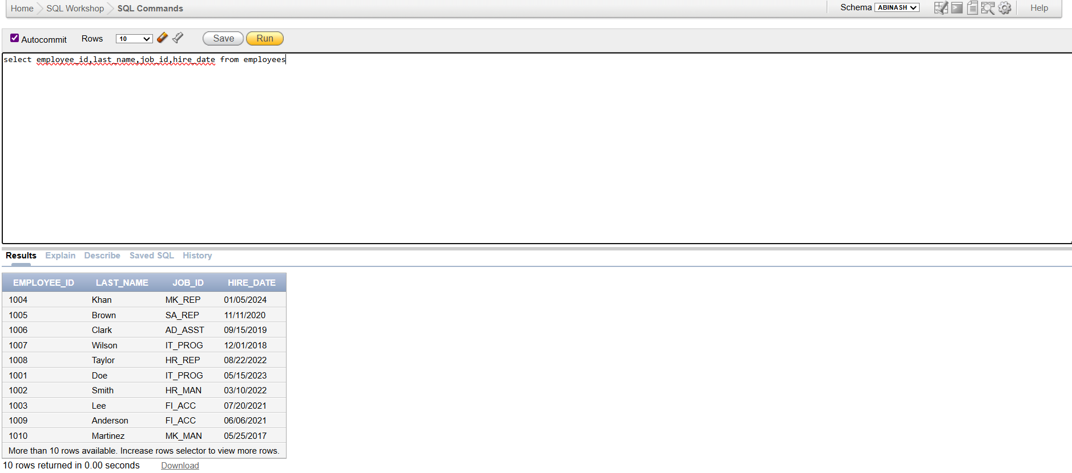

4.Provide an alias STARTDATE for the hire date.

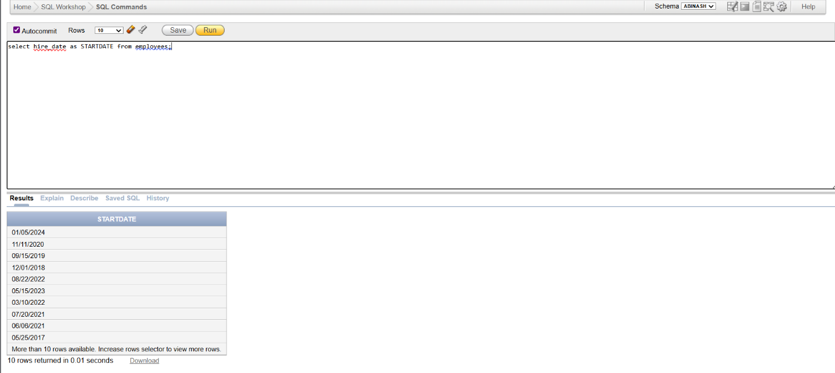

5.Create a query to display unique job codes from the employee table.

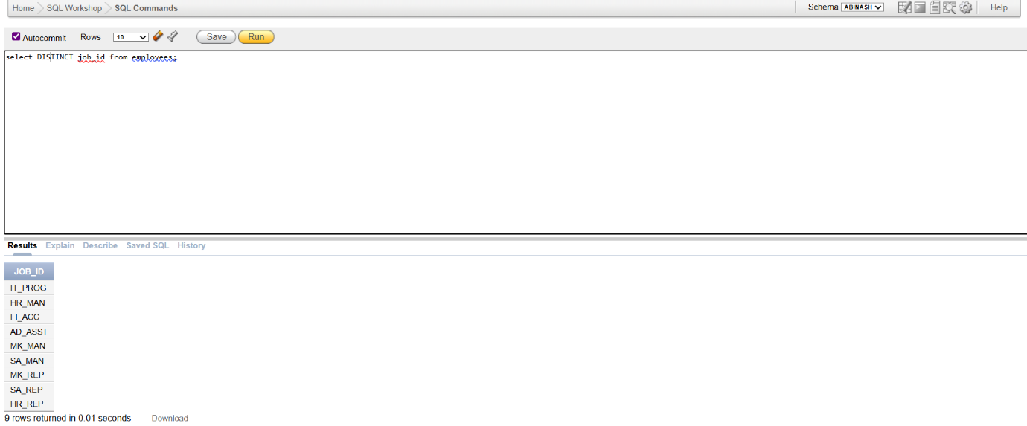

6.Display the last name concatenated with the job ID , separated by a comma and space, and name the column EMPLOYEE and TITLE.

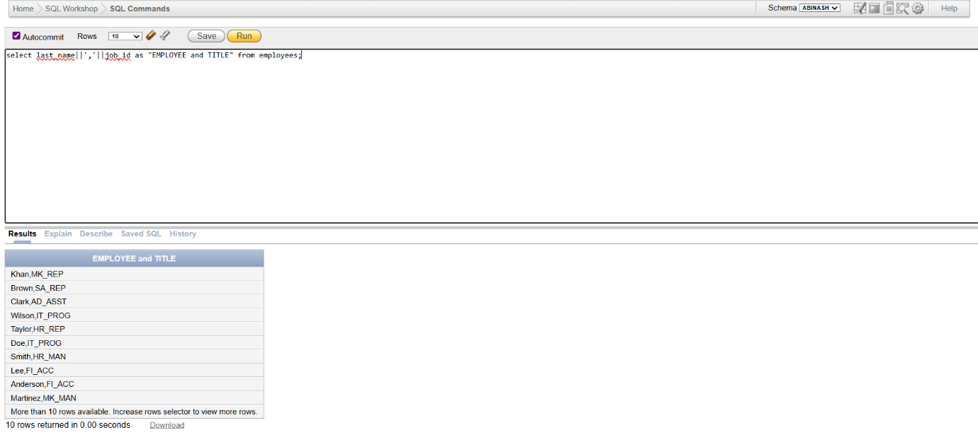

7. Create a query to display all the data from the employees table. Separate each column by a comma. Name the column THE_OUTPUT.

